Paris Senior Center
October 2019

October 5th- Do Something Nice Day October 8th- Pierogi Day
October 12th- Paris Pwnpkin Fall Festival October 14th- Columbus Day
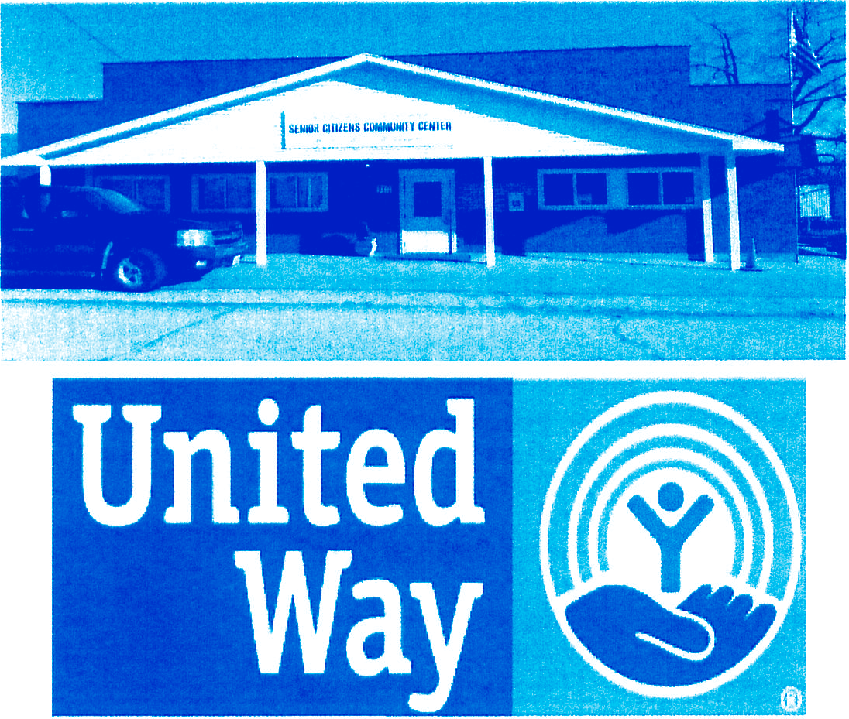
October 16th- Boss' s Day October 27th - Na vy Day October 31st- Halloween
112 E. Marion
Paris, Mo. 65275
Tara Garside / Administrator 660-327-5824
www.parisseniorctr@gmail.com Check us out on Facebook at: Senior Citizens Community Center www.parissen iorcenter.com
Gemstone- Opal
Zodiac- Libra & Scorpio Bird- Swan
Flower- Marigolds

Downs Syndrome Awareness Month National Senior Center's Month

Partnerships and collaborating with these organizations helps us make a difference in the lives of the people we serve in our community. Thank You

Newsletter 1

  - Paul Martin

  - Joe Colston
  - Whitney Callison Ed Mershon
Dannie Reynolds
10-9 Twilla Allred Lori Gough Brenda McGee Kyle Middleton Andy Norris
10-14 Trenton Morgan

Beverly Rex Dorothy Tillman 10-15 Gail Oliver
10-16 Nina Hildebrand

Mackenzie Wilkerson Tyler Wilkerson
Diane Vanlandingham , Sharon Hillard 10-10 Grace Reynolds Ed Mitchell

  - Kathy Barnes Joy Crites
Delmar Fisher lack Johnston Jared Kendrick Jim Meeks Roni Sinkclear
  - Violet Wilkerson
  - RonBridgeman
Randy Davis Jerry Hartel Norman Olson John Turner
  - Charles Davis Jimmie DeOrnellas Andrea Herron
Michael Roberts Amanda Shumard
  - Glenda Turnbough
  - Kent Blades
  - Ernie Baker Lou Lemon
Betty O'Bannon
Ruth Phillips

  - David Watson
  - Jackie Sutton
10-13 Quentin Ashenfelter Henry Schaefer Ashley Mitchell 10-20 Norma Denny

10-8 Jan Smiley Carter
Kaley Maupin Billy Harmon
  - Rita Arnett
  - Don Johannaber
10-26 Shelly Painter Taylor Warbritton 10-29 Ann Chilcoat Peggy Warren
Sue Little DanSharp
10-14 Zemo Beaty
Billy Darst Keith Dowell Michelle Garner
10-24RobbiTurner Edith Talley Margaret Olney Juanita Hunt
  - Joe Crist
  - EvaCharlick
Donna Morgan
Gladys Shuck
10-21 Jimmie Dye Judy Langerud
10-25 Nancy Riechmann Becky Vanlandingham Diane Holmes
Kathy McCoy Wayne Hewett Keith Hillard

660-327-5824
Open M-F 8-3pm
Paris Senior Center Menu
Oct-19
Lunch 11-1230

Sday Monday Tuesday Wednesday Thursday Friday Sday
 | ###############  Chef's Salad is available as alternative  to hot meal  ############### | 1. Meatloaf | 2. Chili | 3. Roast Beef  M. Potatoes/Gravy Green Beans Daffodil Cake Whole Grain Roll  Fruit | 4. Fried Chicken | 5
 |  | Mashed Potatoes | Grilled Cheese |  | M. Potatoes/gravy
 |  | Peas and Onions | Sandwich |  | Scalloped cabbage
 |  | Grape Salad | Layer Salad |  | Ambrosia
 |  | Whole Grain Brd | Lemon/Blueberry  Dessert |  | Wheat Biscuit
6 7. Breaded Pork Chop |  | 8. Patty Melt Tater Tots Buttermilk Pie Mixed Fruit | 9. Ham & Beans Fried Potatoes Cole Slaw Louisana Fruit Salad  r"rn Br ad | 10. Oven Baked BBQ Pork Steaks Hashbrown Cassarole Fried Cabba2e Banana Split Cake  Garic Rr12:11d | 11. Fried Chicken M . Potatoes/2ravv Green beans Mandarin Oran2e Cake  Wh at Ricrnit | 12
AuGratin Potatoes
Spinach Strawberrv S.Cake Whole Grain Brd
13 | 14.Chicken & Dumplin | 15. Baked Ham | 16. Country Ribs | 17. Lasagna | 18. Fried Chicken | 19
 | M.Potatoes Creamed Peas  Cotta2e Cheese/Pears Oatmeal Cookie  Bread | Scalloped Potato Butter Beans Pineapple Cake Whole Grain Brd | Sauerkraut Mac n Cheese Brussel Sprouts Lime Pears  Whole Grain Brd | Corn  Lettuce Salad Strawberrv Pie Garilc Bread | M. Potatoes/gravy Carrots Peaches/Bananas Wheat Biscuit
20 | 21. Shrimp  Baked Potato | 22. Spaghetti w/ It Pork Sausage Lettuce Salad Banana Dessert Garlic Bread | 23. Country Fried Steak M.Potatoes Italian Tomatoes Oran2e Salad  Whole Grain Brd | 24. Roast Pork M.Potatoes Carrots Blueberry Cake  Whole Grain Roll Fruit | 25. Fried Chicken Potato Wedges Cole Slaw  Apple Streusel Cake  Wheat Biscuit | 26
 | Spinach Salad
 | Ambrosia
 | Corn Bread or Whole
 | Grain Brd
27 | 28. Catfish Nuggets  Fried Potatoes Cole Slaw  Cottage Cheese/Peach | 29. Meatloaf  M. Potatoes Peas and Onions  Grape Salad | 30. Chili  Grilled Cheese Sandwich  Layer Salad | 31. Roast Beef  M.Potatoes/Gravy Green Beans  Daffodil Cake | ****************  FREE Birthday Meal  on October 23
 | Whole Grain Brd  HushDUDDies | Whole Grain Brd | Lemon/Blueberry  Dessert | Whole Grain Roll  Fruit | ****************

October 2019
sunda M o.nday Tuesday Wedne day l Thursday

Friday

Satu

1 2 13 5

4
I
-/-/
--.!
' ', { .. I ,. ,

6

I
13 14
I S 19 110 I 1 1 The Great I 12
Pumpkin Fall Festival
tomorrow 12th
Lega l Services here

I 1s I 16 I 11 I I 19

20 I

-/ \-/... 1\

22 Michelle's
18
23 124 26

- . w . . / /

ii •. -:
J 21 . -

Birthday
lI'di"C11:....- -

25 .,.

'. 28 Open 129
    - ,,. :·· :· ,; Enrollment for
-''l:. '
30 Susie's 31
Birthday

·· Medicare Part D
-· ..:ct: .•-i- 9-3:30
· ·:,,..'# . •. 1
-

- Appointment Only
Folklife Festival in Hannibal 19th & 2Qth
United Way

Calendar Template© calendarlabs .com

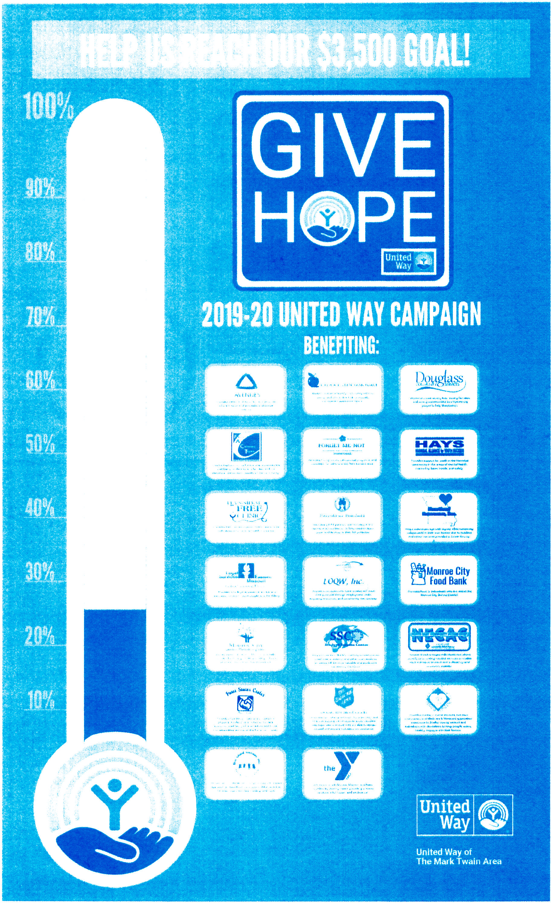

UNITED WAY COOKBOOK RECIPE OF THE MONTH

$500 Union Station Cookies
Ingredients
1 C Butter
l C Brown Sugar 1 C White Sugar 2 Eggs
1 tsp vanilla extract
4 oz. Hershey Bar, melted 2 C Flour
l tsp baking powder
2-1/2 C Powdered oats (measure before blending) l (12oz) pkg. Chocolate Chips
  - /2 C Chopped Pecans

Instructions
Cream butter, sugar, eggs and vanilla. Stir in remaining ingredients. Drop by teaspoonful onto ungreased cookie shee ts . Bake at 350 degrees for 8 m i nu tes . Yield 4 dozen.
Respectfully submitted by: Carol I laga n- Monroe City R- 1 School District
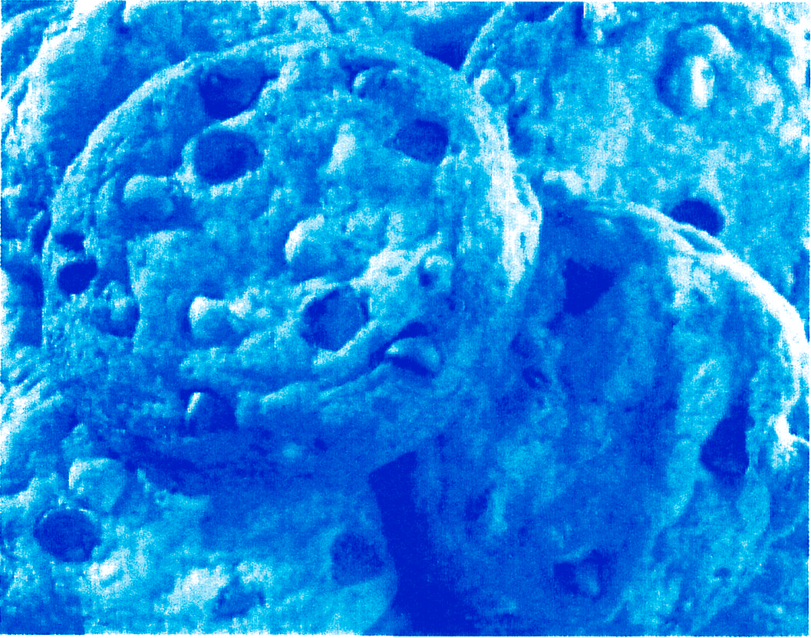

Get your United Way of the Mark Twain Area cookbooks at our Senior
Center while they last!!

Newsletter 1.3

To schedule a ride in Monroe County call the OATS office at 800-654-6287.
Fares (one-way):
    - $2.00 for in-town riders
    - $3.00 for county service
    - $4.00 going to an adjacent county
    - $10.00 round trip (or $6 one-way) for long distance travel
    - $1.00 fee for each en-route stop
Seniors 60+ and Individuals with disabilities 18-59 riding under the AAA contract do not have a set fare but are asked to contribute a minimum amount for their rides.

To Hannibal: 3rd Friday each month
To Mexico: 4th Friday each month
To Moberly: 1st & 3rd Tuesdays each month & 2nd Thursday each month
To Monroe City: 2nd Friday each month
To Monroe City & Monroe City In-Town: 1st Wednesday in Feb, Apr, June, Aug, Oct & Dec*
To Paris & Paris In-Town: 4th Tuesday each month
To Quincy: 2nd Monday each month

From Monroe City to Hannibal: 1st Friday each month (Arrive 7:00, Depart 10:00)

From Paris to Moberly: Mondays, Wednesdays & Fridays (Arrive 10:30, Depart 2:45)

*County Committee Meeting: Monroe City Nutrition Site, 12:30 p.m. All OATS meetings are open to the public!
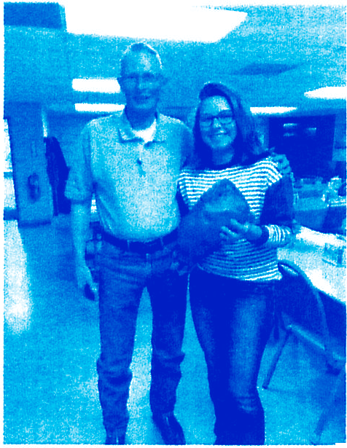
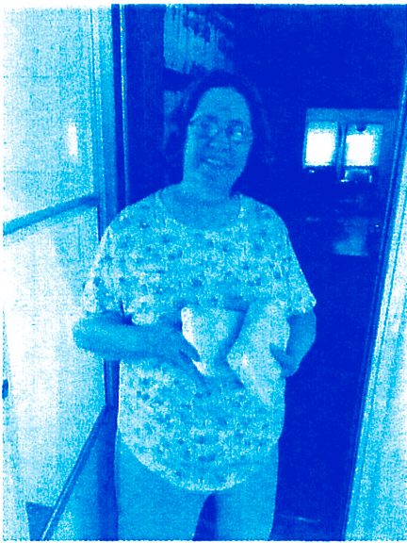
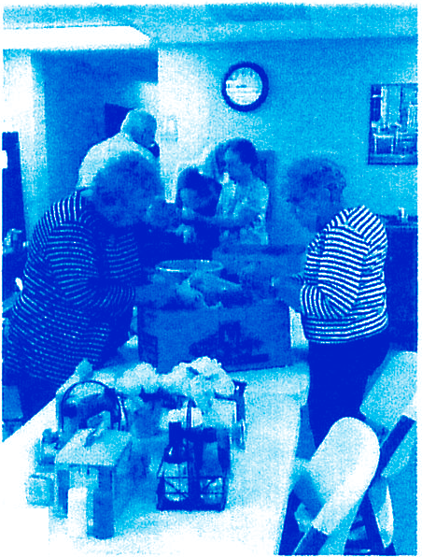
·
Country Ham donated by Chuck Brezeale & Molly McGee Corn donated by Matt Bross & daughter's Autumn & Shiloh
Aly's Project pigs delivered to home delivered clients Bonita & Delmar Fisher

Stop by TPNB Bank EVERY Friday in October

for your bag of homemade cookies!!
Each bag is $2.QQ with all proceeds going to the Monroe County Cancer Supporters.
Member FDIC

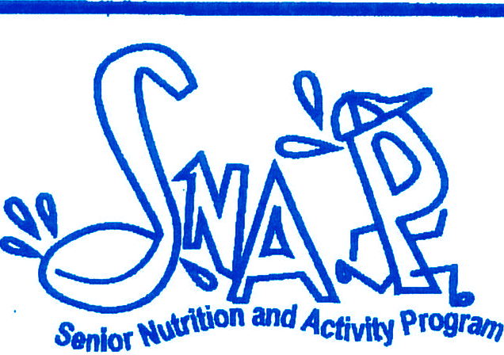A Progam of Senior Services, Inc. of Wichita Phone:(316)267-0302 •Fax: (316)267-0805
+

E,uoying Alcohol...
In Moderation
by Cindy Reimer, LO.., R.D... American Red Cross..
Good. Neighbor Nutrition Program

Alcoholic beverages traditionally are served to enhance and/or add pleasure to eating. When used in moderation, some forms of alcohol are also thought to provide possible health benefits.

The key to these potential health benefits is moderation, which means no more than one drink per day for women and two for men. One drink is 12 ounces of beer, 5 ounces of wine, or 1.5 ounces of 80 proof distilled spirits.

Excessive drinking of alcohol increases the risk for injury, illnesses, and even death. The potential of protecting your heart is not a good reason to start drinking if you don't enjoy it. If you like a glass of red wine with a meal, there may be health benefits.
►Moderate use of alcohol may:
Provide protection from heart disease, particularly red wine.
►
Antioxidants in red wine may help increase HDL,"good,, cholesterol levels, & may prevent LDL's,"bad"cholesterol, from being oxidized.
►
Help control abnormal blood clotting, a risk factor in heart attacks.

Other lifestyle habits like healthy eating, regular exercise, and not smoking actually offer the most protection from heart disease.

For more information about this topic visit the American Dietetic Association (ADA) Web site at www.eatright.org or call the ADA Consumer Nutrition Hot Line at 1-800-366-1655 for a referral to a dietitian in your area.

The SNAP Project Is Funclecl By The Kansas Health Founclation

<Ja'W i+.. .
liked i+. . .
told .• •
ao+ i+H

.- I .
OONTt.ORGET. ''fNt DTo
.
1cv of' l il ·.
i,L•.,i11
ni
i11 t h. is
It's /i.1111w lwll'
\\'l'
it1u-n

i OO RE WH-T
-
l. ,
E TA
•c n U1ot Ph
l"'-,
i
a! t/i(l -rc11[ l mes
c,
in•

OIJ_{t} _{AT} .SKINNY
LIi;· · RION.
,mtl 11!.i L· cs.
L1lll" ,,,lf /is LT (1 S S

" 'it Ii l,!l1LTs
,s t
l hal \\ 'l'

- nwy sh.H"L' citu- ll)\ 'l', l
. )
- ,1[ i l111s. md
n
sc
- l11111 1;1s
ob
s i L111.

thal I a pp Yccinlt'. ,111:1 chaish.
design n/'Cod
This is a
lw11l'.

10 FUN FACTS
- You can't see your ears without a mirror.
- You can't count your hair.
- You can't breathe through your nose, with your tongue out.
- You just tried # 3
- When you did #3 you realized that it is possible, only you look like a dog.
- You are smiling right now because you were fooled.
- You skipped #5
- You just checked to see if there is a #5
- Share this with a friend and have some fun.
HAVE A FANTASTIC DAYIIIII

Newsletter 11

P.'A.'JUS S'E:NIO C'E:NI''E 1l0.'A. '1J :M'E:M1l'E'RS

Laurie. (jossett-Cliairman Jo 'Reynofds-Yice Cliairman
Christina Wormineton- Secretary/'rreasurer
.'A.neefa 1laker Xim :Mitclie{{
:Mari{yn 0'1lannon 'rerry :MCCameron 'rony Cofeman

CATERING

Let us make your family's favorites. Whether it's our hand breaded crispy fried chicken or slow oven roasted meats, delicious baked goods, or your Let us make your family's favorites. Whether it's our hand breaded crispy fried chicken or slow oven roasted meats, delicious baked goods, or your favorite side dishes we can help make your events and parties a success.
We offer a variety of options OR you can create a menu that works for you. All items also sold individually please call for prices.
Our staff and volunteers can cater to your group in our facility OR you can rent our facility for your private gatherings, birthdays, anniversaries, showers, parties, etc.
Scheduled pickups and local delivery available.

Newsletter 4

Memorials

We are selling memorial plaques here at the Senior Center. We have two different sizes:

Small- $25 (placed on front of building) size - 7 ½ X 2 Large- $35 (placed on side of building) size - 8 X 4

You can choose from Proud Supporter or In memory of for each of the plaques. For more information please call 660-327-5824 and ask for either Tara or Laurie.

•••••••••••••••••••••••••••••••••••••••••••••••••••••••••••••••••••••••••••••••
LONG TERM FINANCIAL SUPPORT

Please consider leaving a gift to the Senior Center in your will. Your contribution will ensure continued operation of the Senior Center for years to come.

**********************************************
******

ADOPT - A - SENIOR

In November 2008, our Adopt A Senior Program was implemented to help those seniors unable to afford the suggested donation for meals.
If you would like to assist someone in need with daily hot meals; contact our office personnel for more information.
660-327-5824
•••••••••••••••••••••••••••••••••••••••••••••••••••••••••••••••••••••••••••••••

Premier Healthcare is at our Senior Center every 3rd Friday of each month. They will check your blood pressure and provide nail care. This seNice is free but they will take donations.
Monroe County

HEALTH DEPARTMENT

Monroe County Health Department does a free blood pressure clinic at our senior center on the 3rd Thursday of every month.

Calling all Honor Flight Participants

This year The Paris Chamber of Commerce in partnership with the Paris Senior Center would like to honor all veterans in our area who have participated in the Honor Flight at our Third Annual Great Pumpkin Festival at 0745 (we will begin at 0800) on October 12, 2019 at the Paris Fairgrounds, Paris, MO. In addition to the Honor Flight participation, the Missouri Military Academy will provide music, as well as support from the Patriot Guard and American Legion Rid ers.
Please consider joining the festivities and allow us to raise awareness of this wonderful program for our veterans? You can RSVP to Paris Senior Center by email at www.parisseniorcenter.com, by mail at 112 E. Marion Street, Paris, MO 65275 or by calling between 8 a.m. and 2 p.m. at 660-327-5824. We look forward to hearing from you and hope you will join us.

Tara Garside Administrator
Senior Citizens Community Center Paris, MO 65275
Phone: (660) 327-5824
Fax: (660) 327-1025
www.parisseniorcenter.com

Name: ------------------------
Address: -----------------------
Contact information: ------------------
Branch of Service: -------------------
Years served: ---------------------

. ARct 1e: AN1MAI.S So lu tio n on page 22

ACROSS
1 Astray
5 Defect
9 . Front
- Every
- Stringed instrument
- Iraq's neighbor
- Sailors "hey"
- Coral reef
- Belt up
- Spice
21 Aquatic mammal related to the dolphin with spotted pelt and twisted ivory tusk
23 Times
- Chase
- Craze
29 Killer whale
31 Swedish citizen
- Freudian term
- Wilting
37 Judge
39 American symbol
- Poem
- Muslim's religion
- Capital of Peru
- Tie holders
- Long-term memory
- Brands
- Large brown and white gull-like bird found only in cold seas
- Body of water
- . Data transmission rate
54 Voiced
56 Night sky quality
59 Squirrel's dinner
- Animal feet
- Proposal position
- Balances ball on nose
- Revel
- Heron
- Relieve
- Otherwise
- Ding's partner
- Cabbage salad

6 | 7

10 | 11 | 12

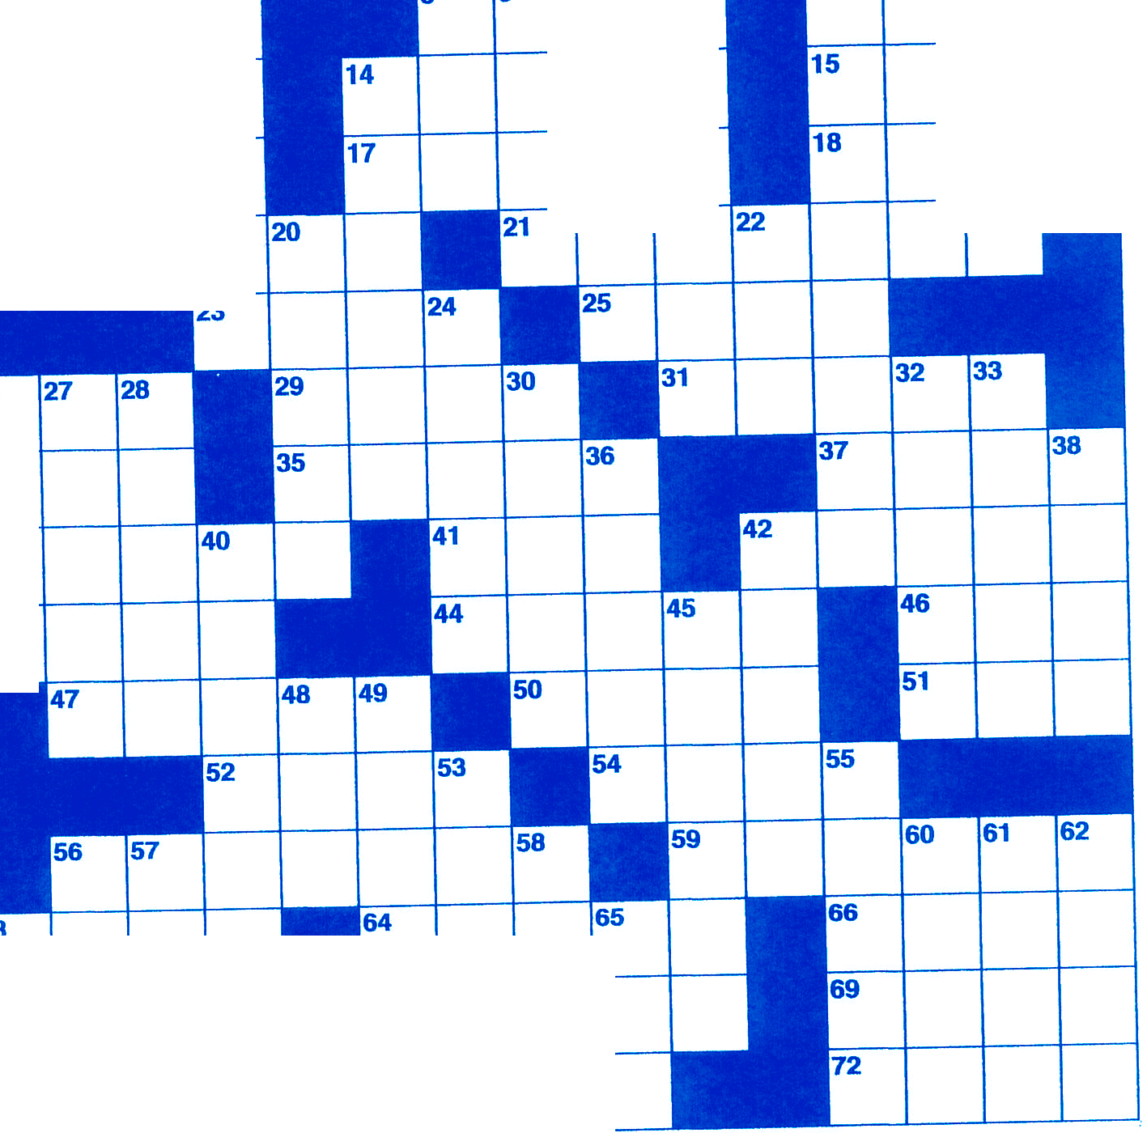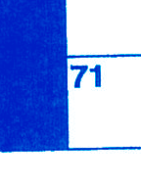DOWN
4
8
19
34

39

43
63
64
70
67
16
13
3
2

1 | Slant | 22 | West northwest | 56 | Go boating
2 | Tropical island | 24 | Descendant | 57 | Deuces
3 | Scotsman | 26 | Touch | 58 | Related to gulls but
4 | Herb | 27 | Do over |  | is smaller with
5 | Belong | 28 | Creed |  | black-capped head,
6 | Diver | 30 | Chilean mountain |  | narrow wings and a
7 | Muslim's God |  | range |  | forked tail
8 | Large marine | 32 | Takes the edge off | 60 | Genuine
 | mammal with two | 33 | Thrill | 61 | Space administration
 | long tusks, flippers, | 36 | Lizard | 62 | Killed
 | blubber and thick | 38 | Austen novel | 63 | Before (prefix)
 | hide | 40 | 'Thrash | 65 | Electroencephalo-
9 | Boxers | 42 | Abraham's son |  | graph (abbr.)
10 | Opera solo | 45 | Charles
11 | Track star - Lewis | 48 | Hearing part
12 | Finish | 49 | Pouted
14 | Impulse | 53 | Wild dog
20 | Eat away | 55 | Doesn't win

BOYS TOWN 2019

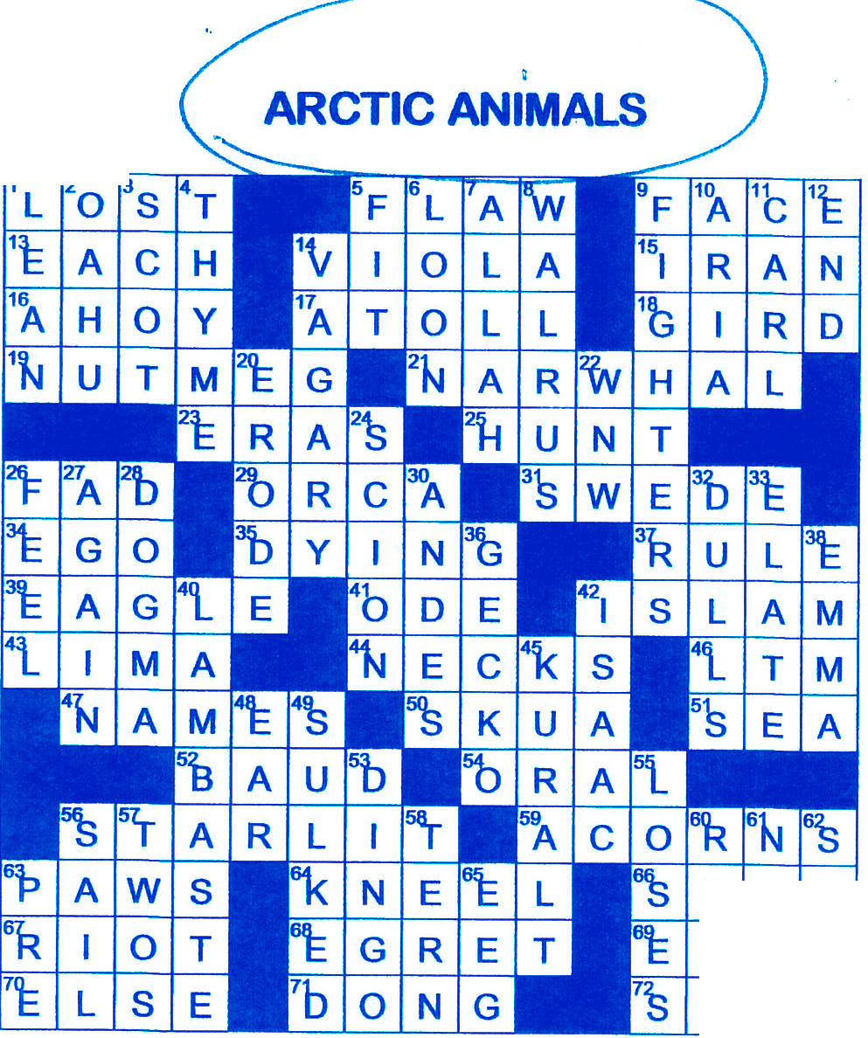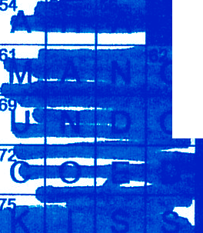 --...
SOLU110N:
SOLU11ON:
E A L
A S E
L A W
C

.,.,_.,._..,_
---- - -- -- -
HINESE NEW YEAR
.- ·-- -•-· •t
-._.
- - - ----
.:..----

--,
-...
, - - - _ J
: =-- - -
. L ;.:;::

1 ==- .
r•- --- - ----·· - ;:::=
=
- - :- -.,..
-==-

. - . --- · ----
· =
::::--- ...-
---=
-.lliilll
llr.r - --
-- ·
-- --- - -----
-,
--
.....
--·
--- --
------4
_ .... r-
--- . -
- - -
-
--
------=
1

-----
--===-- =- '--
-u- - · -- .J
:J
-
liilllll- "•'-
-
-
_:j
- r.,
◄-­
· ·- ···
=
-

ll
-- -····-
.,..
---
L--- ----
- - ---,

..JI
-
-
---
_
-· -

....-.

- - -.:a
-
-..,-
-
- -:=:1
.-
=I •- - - -
1

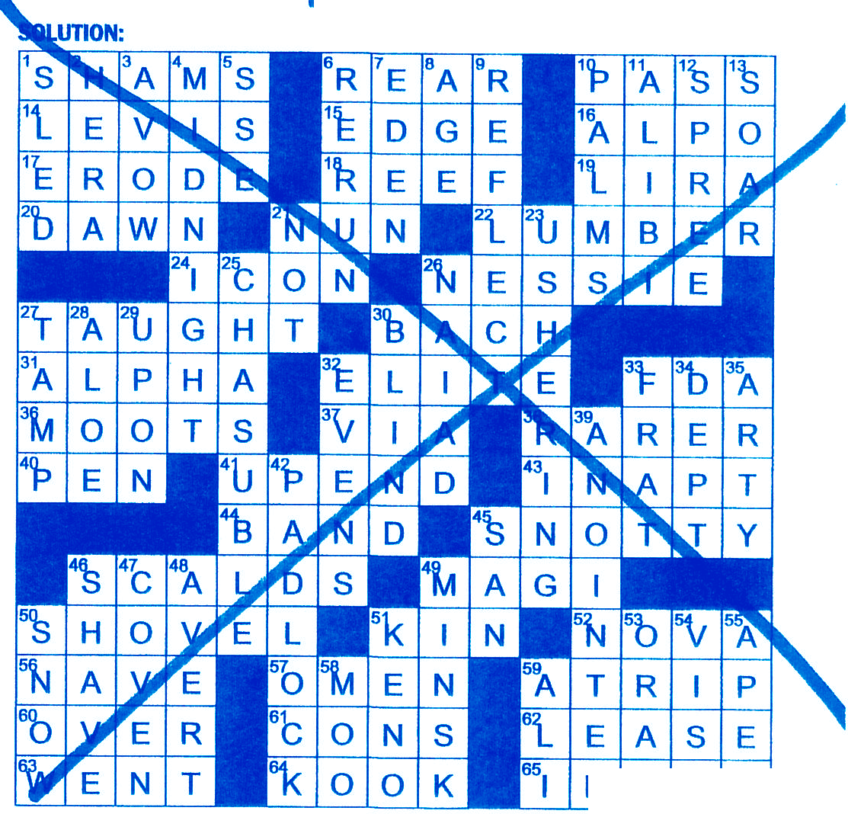CHRISTMAS DECEMBER
D L E D
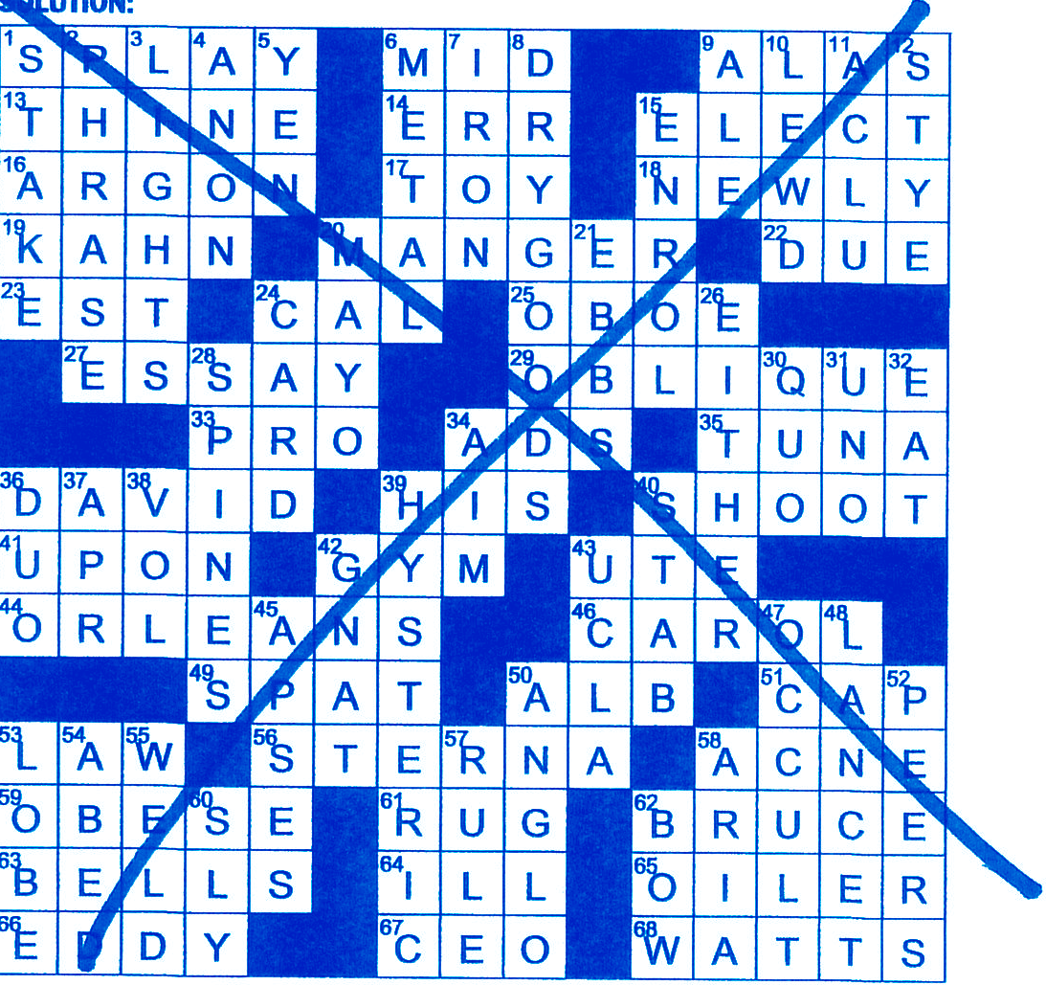

22 Very Merry Crosswords BOYS TOWN 2019

©I J© 1 f
ALL AGES WELCOMEI
NEW RULE: ALL REGISTERED ENTRIES CANNOT BE PRESENT DURING CHILI TASTINGII

REGISTRATION FORM AND FEE $25.00 PER ENTRY. FORMS ON CHAMBER WEBSITE & AT CHAMBER OFFICE:225 MAIN ST

RETURN REGISTRATION FORM AND · PAYMENT TO PARIS AREA CHAMBER BY OCTOBER 9, 2019. (MAKE CKS PAYABLE TO: PARIS AREA CHAMBER OF COMMERCE.

HAVE CHILI AT 4H CONSESSION STAND/PARIS FAIRGROUNDS BY 10 : 30
A. M. SATURDAY, OCTOBER 12.

•

First Place - $100.00 Second Place- $75
m
Third Place - $50

The Great Pumpkin Fall Festival Pumpkin Dessert Contest 2019

Register 12:00-12:45pm Judging starts at 1pm, Free sampling begins at 1:15-1:30pm
The 3rd annual Great Pumpkin Fall Festival, is looking for the best pumpkin desserts 2019. Start searching your recipe books and whip up something wonderful using canned, fresh pumpkin or pumpkin spices in the recipes. Bring only this form filled out with you at check in. Print Clearly. This is a fun, friendly contest for all.
Name

Address

City _
_ _ _ _ _
_ _ _ _ _
_ _ _ State
_ Zip

Telephone _ Email

Recipe Card Y ---- N ----
score if you do not have a recipe card.

Where did you find this recipe?
Note: 10 points will be deducted from overall

- My signing this form, I the contestant of the named contest above, agree to release the organizers of this event, Paris Area Chamber of Commerce & Paris Senior Center, City of Paris, festival staff, judges, and all its affiliates from any loss, damages, or liability for personal injury to myself during the Pumpkin Baking contest on Oct. 12, 2019. I agree to allow photos of my entry and name to be given to the local Medias and to be used on the Paris Area Chamber of Commerce and Paris Senior Center's Great Pumpkin Fall Festival official web site. You agree to donate your entry for the free sampling to festival goers.

Please sign here! Date: 10/12/2019
Categories: You may enter up to (2) items. One per category. Refrigeration provided. Entry # given at check in on Saturday, October 12th at the Fairgrounds 4H Concession stand from 12:00pm - 12:45pm. All recipes must use canned or, fresh pumpkin.
Recipes are accepted with just pumpkin seasonings included also.
ENTRY#
Pumpkin Pie *provide pie cutter

Pumpkin Bread *provide a knife to cut bread

Pumpkin Cookies provide up to 4 dozen for sampling
Pumpkin Cake/Cupcakes provide 4 dozen for sampling
Best Pumpkin Dessert *Examples: Pumpkin fudge, truffles, Pumpkin roll * Bring cutting & serving utensils for this group.

Note: Please tell your friends and have fun creating something wonderful. See our website www.parismochamber.com for registration forms.

GENERAL INFORMATION & RULES

Judging: A panel of judges will sample each entry. Judges will be looking at the presentation, taste, texture and appearance. Entries will be scored and the winner with the highest score will be announced. A recipe card for each entry is required.

Prizes: 1st to 3rd place in each group.
A combination of gift baskets, gift cards, dinner for two, candles, home decor' will be awarded to winners.
Rules and Requirements

  - Contestants, are to help serve free samples to festivalgoers.
  - Please print up at least 50 copies of your recipes to give out to festival goers sampling your amazing desserts. Any size paper will do.
  - Pumpkin Festival staff will provide silverware, paper plates, bowls, napkins and some serving utensils.
  - Each contestant may enter up to (2) items. Only one per category.
  - The recipe card will be kept by Pumpkin Festival organizers. These recipes are being collected for a Pumpkin Festival Cookbook. Your recipes will be added to the Pumpkin Festival recipe booklet.
  - Sampling to festivalgoers starts immediately after judges have received samples of all the entries. Awards will be announced around prior to sampling, covered pavilion.
  - Think about the way your entry will be on display. Be creative!
  - You must be present to receive your prize. All entries must use some form of fresh or canned pumpkins or pumpkin seasonings in the recipes.

Entry must be created or baked by you! No store-bought products

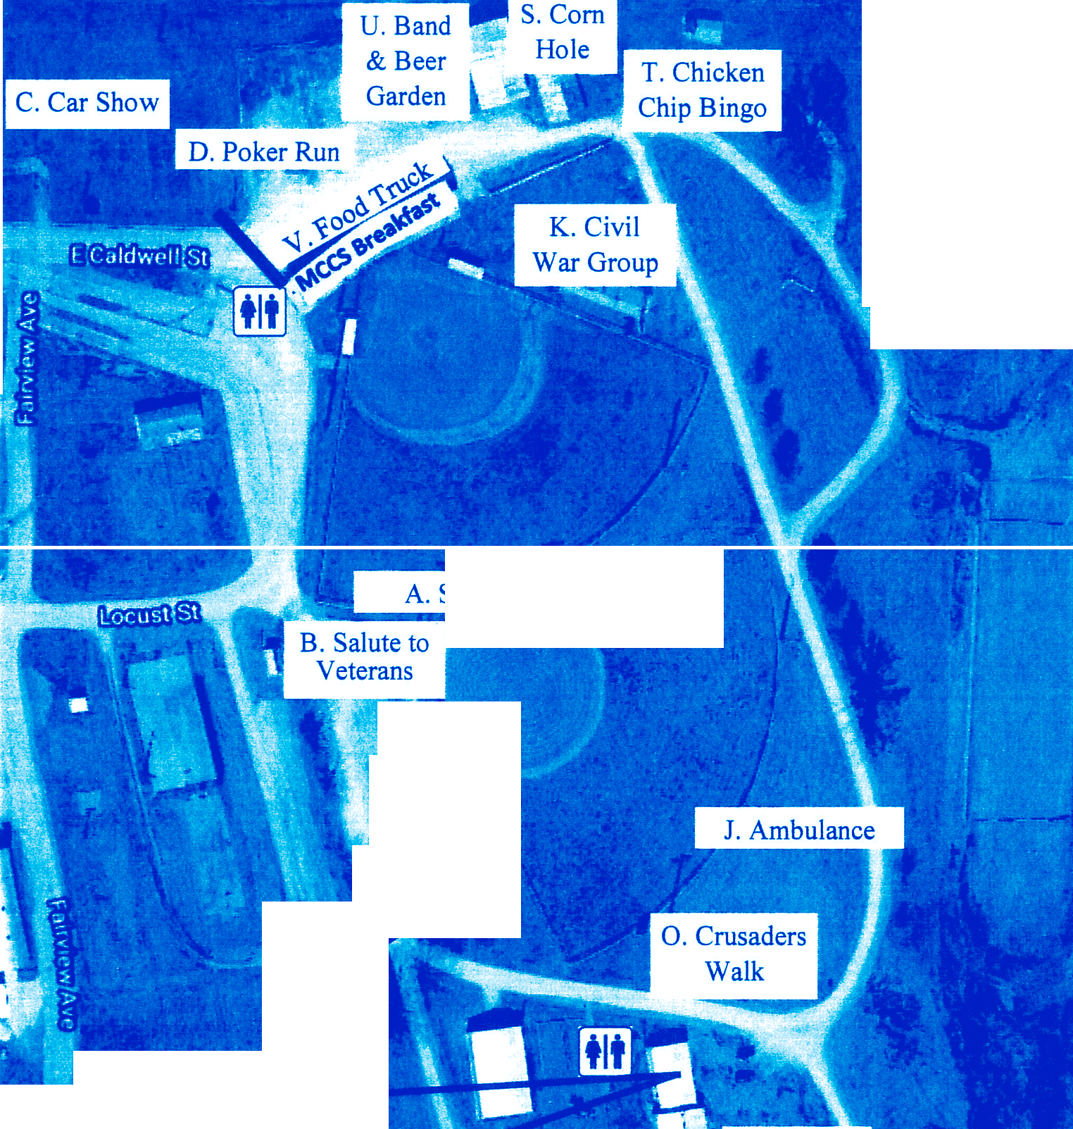Welcome to the 3rd Annual Great Pumpkin Fall Festival
N. Pumpkin
Haul
M. Turkey
Shoot
!I
A. S ball Tournament I
□
f R. Chili Contest J
[ Contest
Q. Pumpkin
J
I
E. Health & Safety Fair

P. Monroe County Historical Society

List of Events and Times

Welcome Desk: Maps and Merchant Passports available and Duck Race tickets
- Softball Tournament - begins at 8:00am
- Salute to Veterans - 8:00am
- Car Show-
8:00am - 10:00am - Registrati on, 10:00am - 8:00pm- Show
- Poker Run -
9:00am - 10:00am - Registration, 10:00am - Start time
3:00pm - Finish Time, 3:30pm- winner announcement , 3:45 - raffle winner announcement
- Health & Safety Fair - 10:00am - 2:00pm
- Vendors - 10:00am - 3:00pm
- Farmers Market - 10:00am - 3:00p m
- Kid Zone - 10:00am - 3:00pm - corn wagon, Serengeti Steve and this reptiles (1:00-3:00), bounce house, games, pumpkin painting, face painting and much more.
- Petting Zoo - 10:00am - 3:OOpm
- Ambulance- 10:00am - 3:00
- The Wild Bunch Civil War Group - 11:00am - 3:00pm
- Talent Showcase - 11 :00am - 4:00pm
- Turkey Shoot - 11:00am - 1:00 - children (15 & under), 4:00pm - 6:00pm(16 & over)
- Pumpkin Haul Obstacle Course - 11:00am - Registrati on, 12:00pm - Start time 0. Crusaders Walk - 1:00pm
- Monroe County Historical Society Registration Tent
- Pumpkin Food Challenge - 1:00pm - 1:45pm - Registration , 2:00 Judging, 2:30pm - 3:00pm sam­ ples

Lions Club Duck Race - 3:15pm at Courthouse Fountain (tickets available at Welcome Desk)

- CHILI CONTEST - Entry cutoff at 1:30pm, Contest begins at 3:00pm
- Corn Hole Tournament - 4:00pm
- Chicken Ch ip Bingo - 8:00am - 3:00pm
- Band and Beer Garden - Beer Garden 3:00pm - 7:00pm, Band 3:00pm - 8:00pm
- Food Truck - Zydecos Cajun - 3:00 pm - 8:00pm
Concessions
(North Concession Stand)
Breakfast from 8:00am - 10:00am - Monroe County Cancer Supporters
(South Concession Stand)
Chili Contest & Pumpkin Food Challenge
Road Cl osur es marked wit h a bold line
Democrat Club will be providing golf cart rides throughout the festival if needed.

